Practice 2
The HR department needs your assistance with creating some queries.
- Due to budget issues, the HR department needs a report that displays the last name and salary of employees who earn more than $12,000.
Ans - Select last_name,salary from employees where salary>12000;
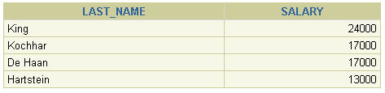
- Create a report that displays the last name and department number for employee number 176.
Ans - select last_name, department_id from employees
where employee_id = 176;
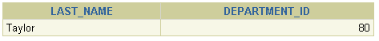
- The HR departments needs to find high-salary and low-salary employees. display the last name and salary for any employee whose salary is not in the range of $5,000 to $12,000.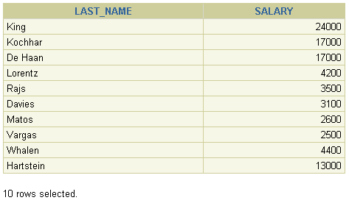
Ans - select last_name, salary from employees where salary>12000 or salary<5000;

- Create a report to display the last name, job ID, and start date for the employees with the last names of Matos and Taylor. Order the query in ascending order by start date
Ans - select last_name, job_id, hire_date from employees
where last_name='Matos' or last_name='Taylor'
order by hire_date;

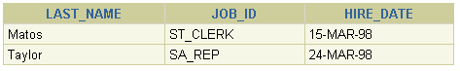
- Display the last name and department number of all employees in departments 20 or 50 in ascending alphabetical order by name.
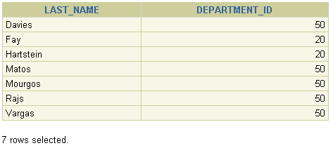
Ans - select last_name, department_id from employees
where department_id in (20,50) order by last_name;

- Display the last name and salary of employees who earn between $5,000 and $12,000 and are in department 20 or 50. Label the columns Employee and Monthly Salary, respectively. 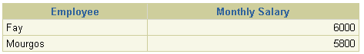

Ans - select last_name "Employee", salary "Monthly Salary"
from employees
where (salary between 5000 and 12000) and department_id in (20,50);

- The HR department needs a report that displays the last name and hire date for all employees who were hired in 1994.
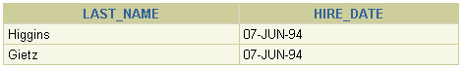
Ans - select last_name, hire_date from employees
where hire_date like '%94';

- Create a report to display the last name and job title of all employees who do not have a manager.
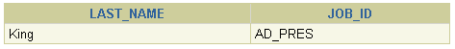
Ans - select last_name, job_id from employees
where manager_id is null;

- Create a report to display the last name, salary, and commission of all employees who earn commissions. Sort data in descending order of salary and commissions.
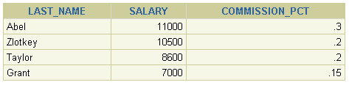
Ans - select last_name, salary, commission_pct from employees
where commission_pct is not null order by salary, commission_pct

